



BPCR Silhouette July 2009

Dave Heeter Wins July Match

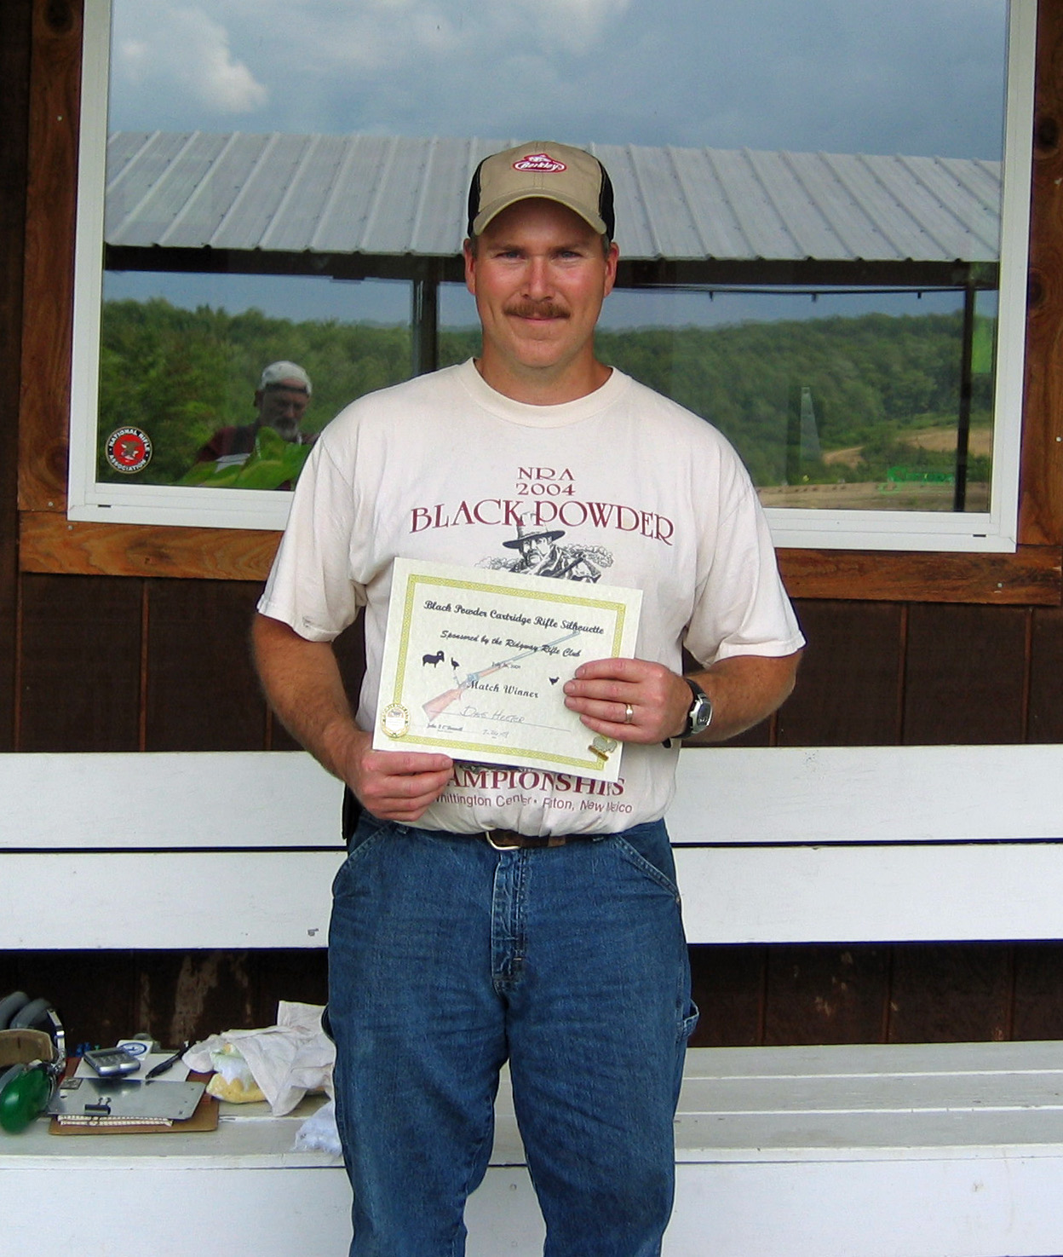

Dave Heeter, of Emlenton, Pa., was the Match Winner of our July Black Powder Cartridge Rifle Silhouette match at the Ridgway Rifle Club in Ridgway, Pa. held on July 26th. Dave knocked down 31 out 40 steel silhouettes to achieve his win. There were a total of 26 attendees for this match.

The weather report for the day was not a good one, but luck would have it, the rain held off until the match was complete. In fact conditions were pretty good with light to moderate winds and only a concern for spotty sunny conditions causing some mirage.

Second Open for match was taken by John Haagen (29) in a shoot off against Ross Arnfield (29) who garnered First Master. Steve Maurer (26) took Second Master for the match. Bruce Getgen fired a 27 to take First AAA with John O’Donnell (26) coming in with Second AAA. Third AAA was won by Richard McKinnis who shot a 25. Another shoot-off followed the regular match to decide First and Second AA between Larry Kiehl (20) and Lorren Brown (20) with Larry edging out Lorren by one turkey.
Dave Heeter – Match Winner
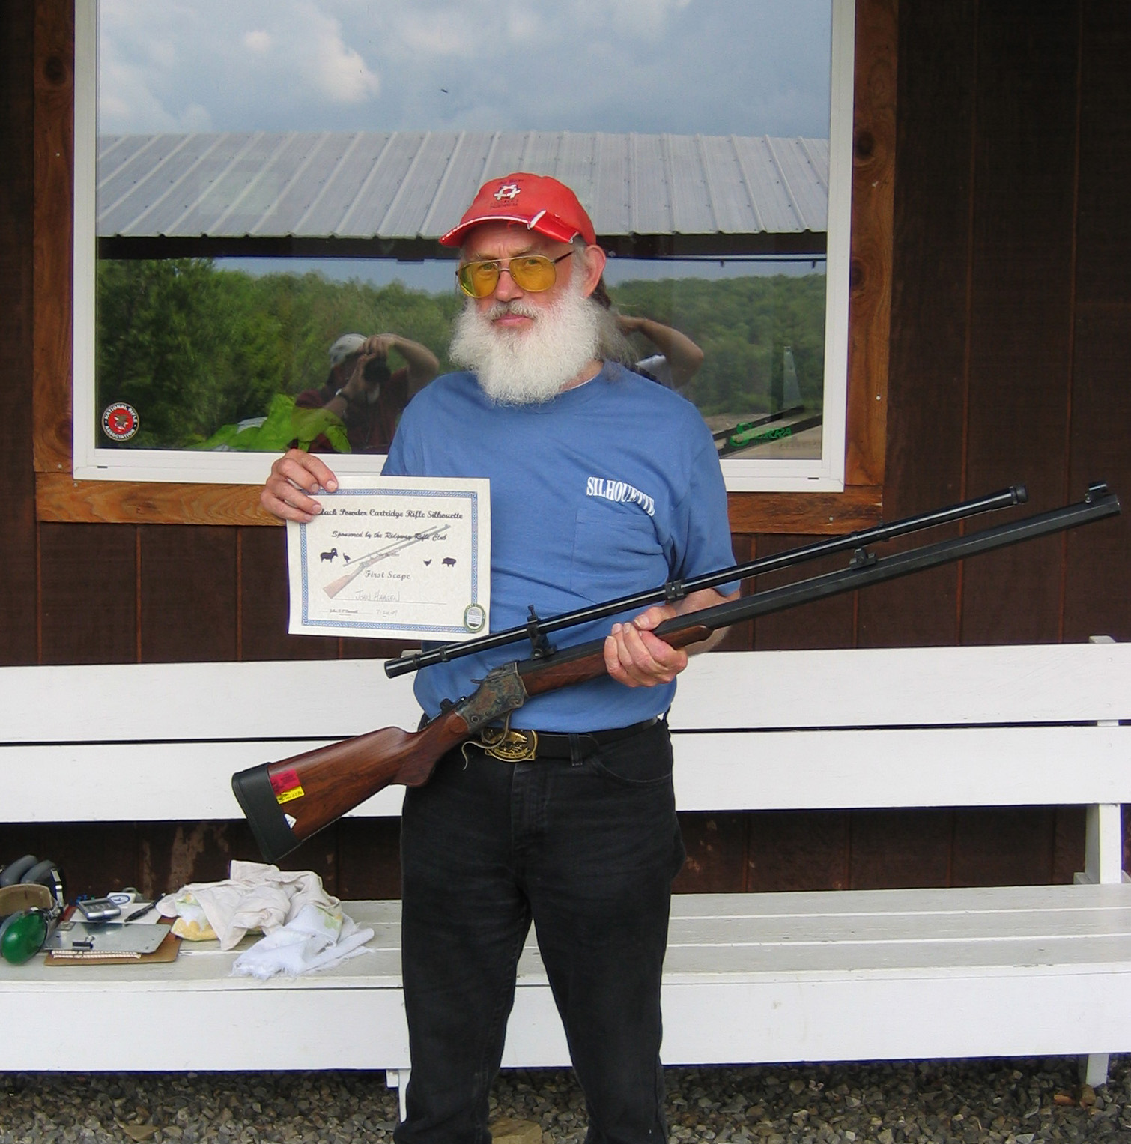
John Haagen with a 31 in scope class was involved in a second shoot-off against Roger Tremba, also with a 31. John won First Scope and Roger took Second Scope. Ed Heeter finished the match with a 28 taking Third Scope.

The Ridgway Rifle Club and all attendees would like to congratulate all the winners. I would like to thank all those who attended and hope you had a good time.

I would like to thank all the volunteers who helped. A big Thank You goes to Craig Artman for setting all the targets up Friday night and helping me paint the steel on Saturday morning. Thanks to Roger Tremba, Karl Nagel and Dave Heeter for calling relays and Steve Maurer for taking the target setters down to the range. Thanks to all those that helped pickup at the end of the match. Another great lunch was brought up by Joey’s Bakery of Ridgway and we thank them also.
John Haagen – Scope Winner

Our next regular match is August 23rd and please don’t forget the 2009 Eastern Regional Black Powder Cartridge Rifle Silhouette Championship September 26th and 27th. I am planning on having an Iron Man class for those of you who want to shoot both Iron & Scope Sights. I hope to see you all there and we should have some nice prizes to give away to the top shooters at the Regional.

Remember to shoot straight, often and don’t forget to involve the younger generation in our shooting sports.

Match Director - John O’Donnell

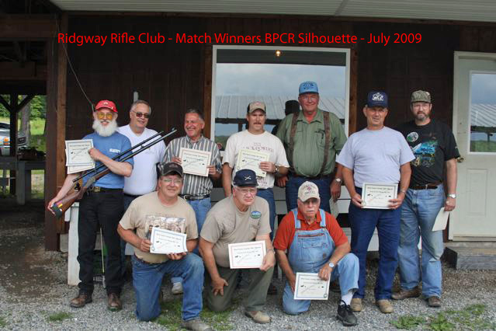
Kneeling L – R: Larry Kiehl, Lorren Brown, Bruce Getgen
Standing L – R: John Haagen, John O’Donnell, Roger Tremba, Dave Heeter, Ed Heeter, Ross Arnfield, Richard McKinnis

